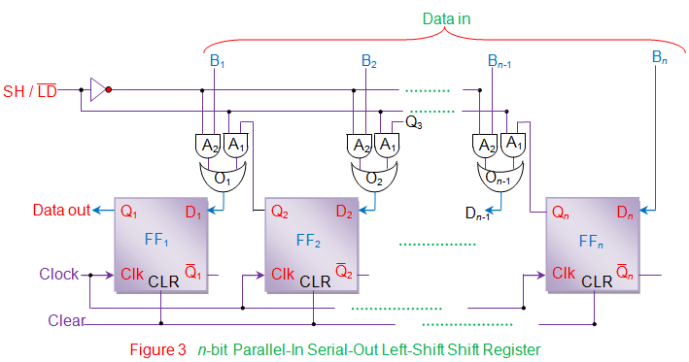

**Figure 1. An n-bit Parallel-In Serial-Out Left-Shift Register. In PISO shift registers, the data is loaded onto the register in parallel format while it is retrieved from it serially.**

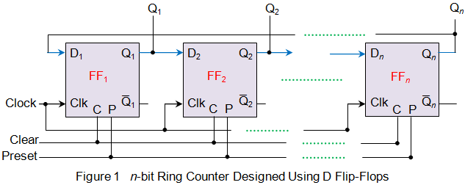

**Figure 2. An n-bit Ring Counter**

**module PISO_LSHIFT (CLK, LD, SHIFT, DIN, Q);**

**input CLK;**

**input LD;**

**input SHIFT;**

**input [7:0] DIN;**

**output Q;**

**reg Q;**

**reg [7:0] SHIFTER;**

**always @ (posedge CLK)**

**if (LD)**

**SHIFTER = DIN;**

**else if (SHIFT)**

**begin**

**Q = SHIFTER[7];**

**SHIFTER = {SHIFTER[6:0], 1'b0};**

**end**

**endmodule**

**module test_PISO_LSHIFT;**

**reg CLK;**

**reg LD;**

**reg SHIFT;**

**reg [7:0] DIN;**

**wire Q;**

**PISO_LSHIFT s1 (CLK, LD, SHIFT, DIN, Q);**

**always**

**#5 CLK = ~CLK;**

**initial**

**begin**

**CLK = 1'b0;**

**DIN = 8'b10101101;**

**LD = 1'b1;**

**SHIFT = 1'b0;**

**#6 LD = 1'b0;**

**#2 SHIFT = 1'b1;**

**end**

**endmodule**